CASP 13 target: X0968
Cross-linking mass spectrometry data for H0968

Protein information (as provided)
CASP13 target: X0968
Protein Name: B5Y0C2
Organism Name: Klebsiella pneumoniae 342
Amino acid sequence: CPX200215
A
VPEITTAQTIANSVVDAKKFDYLFGKATGNSHTLDRTNQLALEMKRLGVADDINGHAVLAEHFTQATKDSNNIVKKYTDQYGSFEIRESFFIGPSGKATVFESTFEVMKDGSHRFITTIPKNGVTK
B
MFIENKPGEIELLSFFESEPVSFERDNISFLYTAKNKCGLSVDFSFSVVEGWIQYTVRLHENEILHNSIDGVSSFSIRNDNLGDYIYAEIITKELINKIEIRIRPDIKIKSSSVIR

Methods
The target protein complex was cross-linked and analyzed by mass spectrometry as described here:
Lysine-specific chemical cross-linking of protein complexes and identification of cross-linking sites using LC-MS/MS and the xQuest/xProphet software pipeline. Leitner, Walzthoeni and Aebersold. Nature Protocols, 2014. DOI: 10.1038/nprot.2013.168
Chemical cross-linking/mass spectrometry targeting acidic residues in proteins and protein complexes. Leitner, Joachimiak, Unverdorben, Walzthoeni, Frydman, Förster and Aebersold. Proceedings of the National Academy of Sciences of the United States of America, 2014. DOI: 10.1073/pnas.1320298111

The concentration the protein complex was adjusted to avoid over-cross-linking, e.g. introduction of non-native oligomerization states.
All cross-linking reactions were followed by SDS-PAGE.

Cross-links identified by mass spectrometry *
Inter protein XL
Protein1 | Protein2 | AbsPos1 | AbsPos2 | ld-Score | Chemistry
A | B | 35 | 98 | 23.97 | ZL
Intra protein XL
protein 1 | Protein 2 | residue | residue | ld-Score | Chemistry
B | B | 98 | 110 | 39.12 | DSS
B | B | 63 | 108 | 37.18 | ZL
B | B | 93 | 94 | 35.93 | ZL
B | B | 89 | 98 | 34.53 | ZL
B | B | 100 | 110 | 25.49 | ZL
A | A | 26 | 45 | 41.54 | DSS
A | A | 102 | 75 | 34.77 | ZL
A | A | 102 | 126 | 33.81 | ZL
A | A | 88 | 126 | 32.01 | ZL
A | A | 61 | 1 | 31.31 | ZL
A | A | 121 | 88 | 31.12 | ZL
A | A | 88 | 75 | 31.03 | ZL
A | A | 61 | 1 | 30.28 | ZL
A | A | 97 | 45 | 29.6 | DSS
A | A | 1 | 76 | 26.29 | DSS
A | A | 35 | 45 | 25.92 | ZL
A | A | 51/52 | 1 | 25.89 | ZL
A | A | 121 | 102/106 | 23.16 | ZL
A | A | 102 | 88 | 22.93 | PDH

* The score is a measure of confidence for the identification of the two connected peptides (i.e. computational assignment) that are identified by MS (the higher, the better). It is generally NOT correlated with the distance between the cross-linked residues. In addition, physicochemical properties of the peptides may affect the identification, so that some cross-linked peptides intrinsically have lower scores.
For the reported data, we expect a false positive rate of identification of approximately 5%.

**Cross-linking chemistries:
DSS: disuccinimidyl suberate – a lysine specific cross-linker.
ZL: Zero-length cross-links formed between lysine and an aspartate/glutamate residue by the coupling reagent 4-(4,6-dimethoxy-1,3,5- triazin-2-yl)-4-methylmorpholinium chloride (DMTMM).
PDH: pimelic acid dihydrazide – a carboxylic acid specific cross-linker (Aspartate and glutamate).

For experimentally observed distance restraints, see following plot (ADH is not used here):
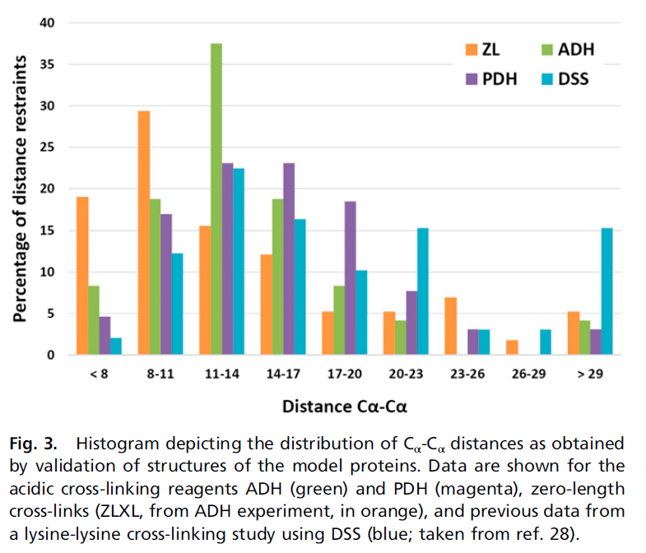
(taken from Leitner et al., PNAS, 2014)

Sub-optimal sequence regions for conventional cross-linking mass spectrometry
Red residues: Lysine residues. Can be cross-linked by DSS and the zero-length cross-linking reagent DMTMM. Cleavage sites for trypsin (protease used in the process).
Black residues: Arginine residues. Cleavage sites for trypsin
Green residues. Aspartate and Glutamate residues. Can be cross-linked by PDH and the zero-length cross-linking reagent DMTMM.

Residues highlighted in yellow are sub-optimal regions for mass spectrometric analysis.

(NO SUBOPTIMAL REGIONS IDENTIFIED)

A
10 20 30 40 50 60
VPEITTAQTI ANSVVDAKKF DYLFGKATGN SHTLDRTNQL ALEMKRLGVA DDINGHAVLA

70 80 90 100 110 120
EHFTQATKDS NNIVKKYTDQ YGSFEIRESF FIGPSGKATV FESTFEVMKD GSHRFITTIP

KNGVTK

B
10 20 30 40 50 60
MFIENKPGEI ELLSFFESEP VSFERDNISF LYTAKNKCGL SVDFSFSVVE GWIQYTVRLH

70 80 90 100 110
ENEILHNSID GVSSFSIRND NLGDYIYAEI ITKELINKIE IRIRPDIKIK SSSVIR

Residues labelled by cross-linking reagents
Red residues: residues labeled by either by DSS (Lysine reactive) or pimelic acid dihydrazide (PDH, reactive towards carboxylic acids), but not cross-linked. These residues are expected to be solvent exposed.

Notes:
Complex formation in the cross-linked sample may not be quantitative, so that exposed regions could only be accessible in the free binding partners.
Absence of a modification may also mean that the corresponding modified peptide is present, but not identified by MS.

Green residues: reactive unlabeled residues.

A
10 20 30 40 50 60
VPEITTAQTI ANSVVDAKKF DYLFGKATGN SHTLDRTNQL ALEMKRLGVA DDINGHAVLA

70 80 90 100 110 120
EHFTQATKDS NNIVKKYTDQ YGSFEIRESF FIGPSGKATV FESTFEVMKD GSHRFITTIP
KNGVTK

B
10 20 30 40 50 60
MFIENKPGEI ELLSFFESEP VSFERDNISF LYTAKNKCGL SVDFSFSVVE GWIQYTVRLH

70 80 90 100 110
ENEILHNSID GVSSFSIRND NLGDYIYAEI ITKELINKIE IRIRPDIKIK SSSVIR

