CASP 13 internal ID: T0985/X0985
Cross-linking mass spectrometry data

Protein information (as provided)
CASP13 internal ID: regular target T0985, XL-MS assisted X0985.
Protein Name: ACL_1061
Organism Name: Acholeplasma laidlawii PG-8A
Amino acid sequence:
10 20 30 40 50 60
MAHHHHHHVG TGSNDDDDKS PMKLKQDVIS IYQKISLFES GQLNITKLAS GAYYLDDELT
70 80 90 100 110 120
LITDPVNSGA RFPYAVNGMT IWAYASGYIS INHSSYYILP PNLEGKEPFL DFFGIEQDGN
130 140 150 160 170 180
NTYPVSLLGV SERNDEIENK RYTVFSKNIA YYITVTKNFL YAVTVYISKD FKIYFNTVAH
190 200 210 220 230 240
NLTGETKQIT LSSFFNMLFK YDSGESIETK WFKKVSYENN MFIYDAPEDI DRHTRIENYG
250 260 270 280 290 300
VVKRHLHTKP KNIQNTTSRI DYVGKRYRSV RNALSIRSLK FEKAPLVTNF TDTAINADLI
310 320 330 340 350 360
NYEVKAYDTI ISSYRIETCH DKDTLNKMMA SDLTDKEIKK VYEGLSNTQS YDFDNFGISF
370 380 390 400 410 420
KGVNDNRVDD KVLNQFLKLV NYQIHFSSLS SNSGTVFLGV RDVMQQLESS LIWDRKNVRS
430 440 450 460 470 480
KILEVLSFID PSGLPPRQYA LPPKEGNPRM DLRPFIDQGL WIISTLHTYL AYTEDYDILN
490 500 510 520 530 540
EVCGYYERIE PNSAKKSKVE NSVLEHLIRV TNYLVSNIDP STYGLKALYG DWNDALDGLG
550 560 570 580 590 600
LIEGSSGYGN GVSVMATLQL YENLERMIEI LKLVDPQNEH INTYEVVRHN LSLGINKYAV
610 620 630 640 650 660
VIKQDEKRVL HGWGHDRSYF VGSFNDPDGH SRNSLTSNAF YIISDMIKNT PEMKPHLLHA
670 680 690 700 710 720
FHNLDSKYGL KTFDPAMQDF HGFGRIINLP PGTAENAATY VHATLFGVLA LYMLGEGDFA
730 740 750 760 770 780
NEQVLKVLPI TKKEMSTSPF IMPNSYVHNE ELNMDGESMS DWYTGSANTL LKTLIRGLFG
790 800 810 820 830 840
LEVKFDHLRL RPSKAFFSKE ATLMVSIGNK LTRIVYKNNN NGNRTFKLNG KVIEAKLDTL
850 860
SGLLYIDINK SILEHQNVIH IQD
Methods
The target protein or protein complex was cross-linked and analyzed by mass spectrometry as described here:
Lysine-specific chemical cross-linking of protein complexes and identification of cross-linking sites using LC-MS/MS and the xQuest/xProphet software pipeline. Leitner, Walzthoeni and Aebersold. Nature Protocols, 2014. DOI: 10.1038/nprot.2013.168
Chemical cross-linking/mass spectrometry targeting acidic residues in proteins and protein complexes. Leitner, Joachimiak, Unverdorben, Walzthoeni, Frydman, Förster and Aebersold. Proceedings of the National Academy of Sciences of the United States of America, 2014. DOI: 10.1073/pnas.1320298111

The concentration of the protein or protein complex was adjusted to avoid over-cross-linking, e.g. introduction of non-native oligomerization states. All cross-linking reactions were followed by SDS-PAGE.

Cross-links identified by mass spectrometry
Inter-chain cross-links*
Protein1 | Protein2 | AbsPos1 | AbsPos2 | ld-Score** | Chemistry***
ACL_1061 | ACL_1061 | 225 | 214 | 34.76 | ZL
ACL_1061 | ACL_1061 | 19 | 25 | 28.97 | DSS

Intra-chain cross-links
Protein1 | Protein2 | AbsPos1 | AbsPos2 | ld-Score** | Chemistry***
ACL_1061 | ACL_1061 | 39 | 140 | 45.65 | ZL
ACL_1061 | ACL_1061 | 799 | 817 | 43.4 | DSS
ACL_1061 | ACL_1061 | 25 | 140 | 43.24 | DSS
ACL_1061 | ACL_1061 | 327 | 444 | 42.75 | DSS
ACL_1061 | ACL_1061 | 140 | 265 | 42.67 | DSS
ACL_1061 | ACL_1061 | 322 | 444 | 42.12 | DSS
ACL_1061 | ACL_1061 | 817 | 827 | 41.77 | DSS
ACL_1061 | ACL_1061 | 800 | 817 | 41.63 | ZL
ACL_1061 | ACL_1061 | 25 | 249 | 41.32 | DSS
ACL_1061 | ACL_1061 | 800 | 794 | 41.17 | ZL
ACL_1061 | ACL_1061 | 251 | 280 | 41.07 | DSS
ACL_1061 | ACL_1061 | 243 | 280 | 39.95 | DSS
ACL_1061 | ACL_1061 | 322 | 25 | 39.73 | DSS
ACL_1061 | ACL_1061 | 265 | 280 | 39.64 | DSS
ACL_1061 | ACL_1061 | 243 | 249 | 38.84 | DSS
ACL_1061 | ACL_1061 | 243 | 280 | 38.77 | DSS
ACL_1061 | ACL_1061 | 322 | 336 | 38.62 | DSS
ACL_1061 | ACL_1061 | 800 | 794 | 38.06 | ZL
ACL_1061 | ACL_1061 | 25 | 243 | 37.61 | DSS
ACL_1061 | ACL_1061 | 336 | 25 | 37.52 | DSS
ACL_1061 | ACL_1061 | 147 | 138 | 37.52 | ZL
ACL_1061 | ACL_1061 | 305 | 25 | 36.95 | DSS
ACL_1061 | ACL_1061 | 838 | 831 | 35.94 | ZL
ACL_1061 | ACL_1061 | 654 | 794 | 35.28 | DSS
ACL_1061 | ACL_1061 | 336 | 243 | 35.13 | DSS
ACL_1061 | ACL_1061 | 243 | 265 | 34.15 | DSS
ACL_1061 | ACL_1061 | 361 | 371 | 34.08 | DSS
ACL_1061 | ACL_1061 | 322 | 265 | 33.4 | DSS
ACL_1061 | ACL_1061 | 231 | 208 | 33.32 | PDH
ACL_1061 | ACL_1061 | 498 | 495 | 33.28 | DSS
ACL_1061 | ACL_1061 | 597 | 605 | 33.15 | ZL
ACL_1061 | ACL_1061 | 249 | 280 | 32.98 | DSS
ACL_1061 | ACL_1061 | 214 | 25 | 32.49 | DSS
ACL_1061 | ACL_1061 | 498 | 444 | 32.31 | DSS
ACL_1061 | ACL_1061 | 336 | 322 | 29.7 | DSS
ACL_1061 | ACL_1061 | 444 | 265 | 29.48 | DSS
ACL_1061 | ACL_1061 | 444 | 243 | 29.41 | DSS
ACL_1061 | ACL_1061 | 339 | 243 | 27.47 | DSS
ACL_1061 | ACL_1061 | 444 | 140 | 27.31 | DSS
ACL_1061 | ACL_1061 | 421 | 444 | 26.63 | DSS

* These cross-links connect two identical residues or peptides with overlapping sequence, pointing to a homo-dimeric contact (native or non-native).

** The score is a measure of confidence for the identification of the two connected peptides (i.e. computational assignment) that are identified by MS (the higher, the better). It is generally NOT correlated with the distance between the cross-linked residues. In addition, physicochemical properties of the peptides may affect the identification, so that some cross-linked peptides intrinsically have lower scores.
For the reported data, we expect a false positive rate of identification of approximately 5%.

***Cross-linking chemistries:
DSS: disuccinimidyl suberate – a lysine specific cross-linker.
ZL: Zero-length cross-links formed between lysine and an aspartate/glutamate residue by the coupling reagent 4-(4,6-dimethoxy-1,3,5- triazin-2-yl)-4-methylmorpholinium chloride (DMTMM).
PDH: pimelic acid dihydrazide – a carboxylic acid specific cross-linker (aspartate and glutamate).
For experimentally observed distance restraints, see the following plot (ADH is not used here):
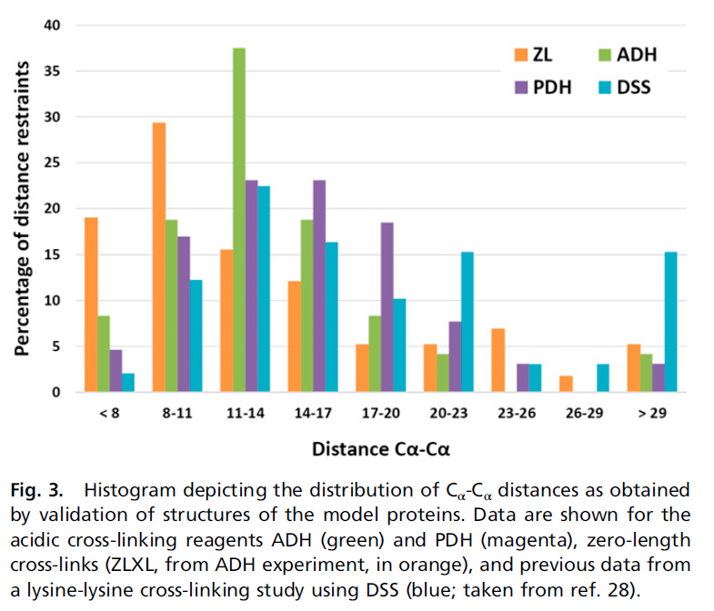
(taken from Leitner et al., PNAS, 2014)

Sub-optimal sequence regions for conventional cross-linking mass spectrometry
Red residues: Lysine residues. Can be cross-linked by DSS and the zero-length cross-linking reagent DMTMM. Cleavage sites for trypsin (protease used in the process).
Black residues: Arginine residues. Cleavage sites for trypsin.
Green residues. Aspartate and Glutamate residues. Can be cross-linked by PDH and the zero-length cross-linking reagent DMTMM.

Residues highlighted in yellow are sub-optimal regions for mass spectrometric analysis.

10 20 30 40 50 60
MAHHHHHHVG TGSNDDDDKS PMKLKQDVIS IYQKISLFES GQLNITKLAS GAYYLDDELT

70 80 90 100 110 120
LITDPVNSGA RFPYAVNGMT IWAYASGYIS INHSSYYILP PNLEGKEPFL DFFGIEQDGN

130 140 150 160 170 180
NTYPVSLLGV SERNDEIENK RYTVFSKNIA YYITVTKNFL YAVTVYISKD FKIYFNTVAH

190 200 210 220 230 240
NLTGETKQIT LSSFFNMLFK YDSGESIETK WFKKVSYENN MFIYDAPEDI DRHTRIENYG

250 260 270 280 290 300
VVKRHLHTKP KNIQNTTSRI DYVGKRYRSV RNALSIRSLK FEKAPLVTNF TDTAINADLI

310 320 330 340 350 360
NYEVKAYDTI ISSYRIETCH DKDTLNKMMA SDLTDKEIKK VYEGLSNTQS YDFDNFGISF

370 380 390 400 410 420
KGVNDNRVDD KVLNQFLKLV NYQIHFSSLS SNSGTVFLGV RDVMQQLESS LIWDRKNVRS

430 440 450 460 470 480
KILEVLSFID PSGLPPRQYA LPPKEGNPRM DLRPFIDQGL WIISTLHTYL AYTEDYDILN

490 500 510 520 530 540
EVCGYYERIE PNSAKKSKVE NSVLEHLIRV TNYLVSNIDP STYGLKALYG DWNDALDGLG

550 560 570 580 590 600
LIEGSSGYGN GVSVMATLQL YENLERMIEI LKLVDPQNEH INTYEVVRHN LSLGINKYAV

610 620 630 640 650 660
VIKQDEKRVL HGWGHDRSYF VGSFNDPDGH SRNSLTSNAF YIISDMIKNT PEMKPHLLHA

670 680 690 700 710 720
FHNLDSKYGL KTFDPAMQDF HGFGRIINLP PGTAENAATY VHATLFGVLA LYMLGEGDFA

730 740 750 760 770 780
NEQVLKVLPI TKKEMSTSPF IMPNSYVHNE ELNMDGESMS DWYTGSANTL LKTLIRGLFG

790 800 810 820 830 840
LEVKFDHLRL RPSKAFFSKE ATLMVSIGNK LTRIVYKNNN NGNRTFKLNG KVIEAKLDTL

850 860
SGLLYIDINK SILEHQNVIH IQD

Residues labelled by cross-linking reagents
Red residues: residues labeled by either by DSS (Lysine reactive) or pimelic acid dihydrazide (PDH, reactive towards carboxylic acids), but not cross-linked. These residues are expected to be solvent exposed.
Green residues: reactive unlabeled residues.

Notes:
Complex formation in the cross-linked sample may not be quantitative, so that exposed regions could only be accessible in the free binding partners.
Absence of a modification may also mean that the corresponding modified peptide is present, but not identified by MS.

10 20 30 40 50 60
MAHHHHHHVG TGSNDDDDKS PMKLKQDVIS IYQKISLFES GQLNITKLAS GAYYLDDELT

70 80 90 100 110 120
LITDPVNSGA RFPYAVNGMT IWAYASGYIS INHSSYYILP PNLEGKEPFL DFFGIEQDGN

130 140 150 160 170 180
NTYPVSLLGV SERNDEIENK RYTVFSKNIA YYITVTKNFL YAVTVYISKD FKIYFNTVAH

190 200 210 220 230 240
NLTGETKQIT LSSFFNMLFK YDSGESIETK WFKKVSYENN MFIYDAPEDI DRHTRIENYG

250 260 270 280 290 300
VVKRHLHTKP KNIQNTTSRI DYVGKRYRSV RNALSIRSLK FEKAPLVTNF TDTAINADLI

310 320 330 340 350 360
NYEVKAYDTI ISSYRIETCH DKDTLNKMMA SDLTDKEIKK VYEGLSNTQS YDFDNFGISF

370 380 390 400 410 420
KGVNDNRVDD KVLNQFLKLV NYQIHFSSLS SNSGTVFLGV RDVMQQLESS LIWDRKNVRS

430 440 450 460 470 480
KILEVLSFID PSGLPPRQYA LPPKEGNPRM DLRPFIDQGL WIISTLHTYL AYTEDYDILN

490 500 510 520 530 540
EVCGYYERIE PNSAKKSKVE NSVLEHLIRV TNYLVSNIDP STYGLKALYG DWNDALDGLG

550 560 570 580 590 600
LIEGSSGYGN GVSVMATLQL YENLERMIEI LKLVDPQNEH INTYEVVRHN LSLGINKYAV

610 620 630 640 650 660
VIKQDEKRVL HGWGHDRSYF VGSFNDPDGH SRNSLTSNAF YIISDMIKNT PEMKPHLLHA

670 680 690 700 710 720
FHNLDSKYGL KTFDPAMQDF HGFGRIINLP PGTAENAATY VHATLFGVLA LYMLGEGDFA

730 740 750 760 770 780
NEQVLKVLPI TKKEMSTSPF IMPNSYVHNE ELNMDGESMS DWYTGSANTL LKTLIRGLFG

790 800 810 820 830 840
LEVKFDHLRL RPSKAFFSKE ATLMVSIGNK LTRIVYKNNN NGNRTFKLNG KVIEAKLDTL

850 860
SGLLYIDINK SILEHQNVIH IQD

